**PROJECT REPORT TEMPLATE**

**M.HARSHINI AND TEAM**

**Introduction:**

**We are created to our project is follow the steps. Our project is INFOGRAFIC DESIGNING by using canva.**

**Empathy Map:**

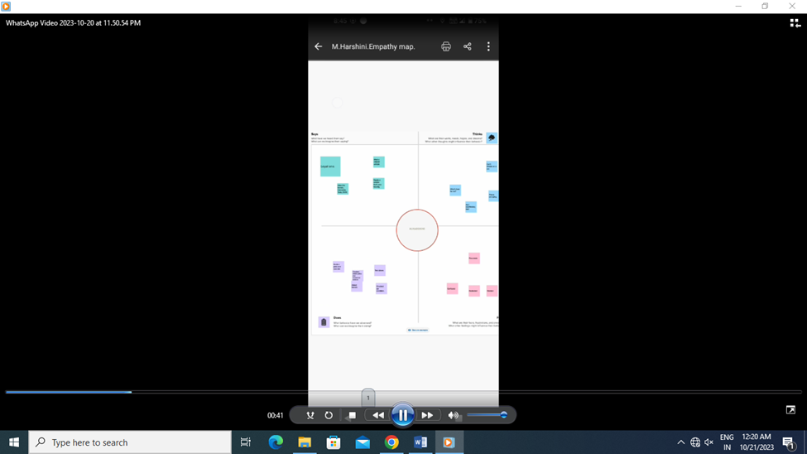

**Brainstorming Map:**

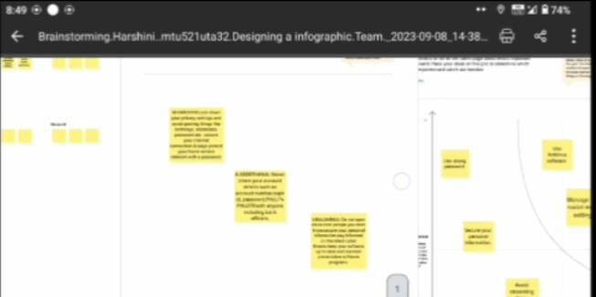

**Canva Design – Info graphic:**

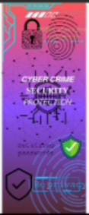

**Conclusion:**

**We are created to our project is follow the steps help of our canva app. Our project is INFOGRAFIC DESIGNING is successfully completed. Thank you.**